**Introduction: what role a career success plays in a person’s life**

Success may be defined by people in different ways, but being a dedicated employee, a strong leader, and an honest person can all make a big difference in making you a successful professional in any career. No matter how you determine your goals, strengthening your skills, building professional relationships, and being a self- motivated specialist can help you to achieve success and satisfaction in your career.

**Factors of career success**

Hard working, self-improvement, get on with people, having some necessary hard and soft skills, be team-focused and adaptable.

Attend all meetings.

Be responsible.

Have healthy ambitions.

Work hard.

Get on with people. 8. Look smart.

Be adaptable/open to new ideas.

Have a sense of humour.

Be aware of modern technologies.

Go to your company's social events.

Be energetic and enthusiastic at all times.

Be the last to leave work every day.

Find an experienced person to give you help and advice.

Study for extra qualifications in your free time.

**hard and soft skills of any successful specialist**

I think successful specialist should compare soft and hard skills and most useful on my mind are:

Management skills, team-oriented, project-management skills, critical thinking, creativity, willingness to learn, flexibility, conflict resolution, presentation skills, attention to details, communication skills, adaptability, stress management, open-mindedness, hard skills depended on kind of job.

**qualities of successful leaders**

Good leader should have developed leadership qualities:

He should be some humble, self-aware, empathy and adaptable. Collaborative, people-focused and passionate to promote team work. He should be able to decisive.

___________________________________________________________________

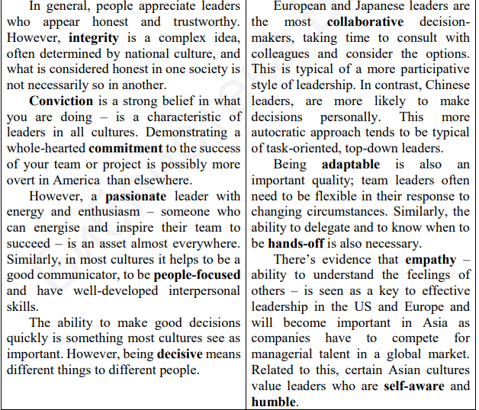

**Principles of business ethics and business communication.**

**Business ethics** means the set of rules or principles that the organization should follow.

Business ethic have some basic principles: leadership, Integrity, respect for others, honesty, responsibility, compassion, loyalty.

**Business communication** is exchanging information and ideas within an organization.

Principles: using different communicational tools, encouraging two-way communication, specific and descriptive feedback

**Variety of jobs in the sphere of information technology**

IT sphere share on main jobs:

1. Mobile application developers
2. Database administrator
3. Web developers
4. IT helpdesk technicians
5. Network specialist
6. Video game developer
7. Graphic designer
8. IT security specialists
9. Software engineers

10) System analyst

11) Computer programmer

12) Hardware engineers

**Typical responsibilities and skills for different IT department jobs**

* Mobile application developers – create software for mobile devices.
* Database administrator – organize and manage a company’s data.
* Web developers - create web pages and web-based applications.
* IT helpdesk technicians – provide technical support and troubleshooting services to end-users, who need help with hardware or software.
* Network specialist - analyse, troubleshooting and evaluate computer network problems.
* Video game developer – use creativity and technical skills to create cutting-edge games.
* Graphic designer – use creativity and technology to create visually engaging graphics that communicate a message.
* IT security specialists – defend an organisations information systems.
* Software engineers – develop computer systems and applications.
* System analyst – manage IT solutions to drive business goals.
* Computer programmer – write the code that fuels computer operation.
* Hardware engineers – design and build computer systems.

**Future skills for IT specialists and their importance**

To stay competitive in our careers, we must not only do our jobs well today, but be prepared for how we'll be doing our jobs well in two, five, ten years from now. So, what skills and experience will be most important in the future? Based on industry trends and where technology is headed, there are some IT skills Emotional intelligence employers will want the next decade.

Most people can pass a certification exam or learn a new software application. But not everyone has an ability to lead a team through a tough project, build relationships with stakeholders, or keep a remote team engaged. Employees should place more emphasis on being able to deal with conflicts, manage a virtual team and deliver on strategy to achieve tangible benefits for the business. We can call them soft skills or emotional intelligence - employers are going to seek out this attribute more and more.

Adaptability

Because of technological advances, shifts in society, and the many unknowns of the future, project managers need to be open to new ideas, flexible to pivot with changing times, and ready to adapt to changes.

Working with and managing remote teams

Working remotely and with dispersed, international teams is on the rise, and employers will be looking for IT specialists who have experience successfully working from home, as well as managing a remote team.

Hiring managers at remote companies are looking for candidates who can communicate verbally and in writing, have an independent streak, and have a track record of successfully managing their own projects

Data science expertise

The Internet of things, automation, and artificial intelligence have been the buzzwords since 2017. These advances are going to shake up every industry in some way. IT management is definitely getting a pass on this one.

For IT professionals, this means that our programs, systems are going to start talking to you. They'll help you to identify risks, detect problems, and unload the administrative tasks through So, there will be an increased need for project managers with big data expertise.

**Personal vs professional vs continuous professional development (CPD)**

Personal development is more focused on communications, time management, and things such as leadership training.

Professional development refers to all training, certification, and education that a worker needs to succeed in his or her career. Different jobs require different skills. Even if a worker currently has the necessary skills, he or she may need additional skills in the future. Through professional development, workers can learn these skills to become better, more efficient workers.

(2) Continuing Professional Development (CPD) is a process of building, maintaining and enhancing your knowledge and skills. CPD helps you to plan your development, review what you have learnt and evaluate the effectiveness of your activity. Your commitment to CPD is important as the activities you choose will help to underpin your validity and competence as a professional.

CPD is not always formal and linear; activities can range from formal educational activities such as instructor-led training courses, workshops or seminars to more informal approaches such as work-based learning or mentoring. CPD can also include self-directed study such as e-leaming courses and structured reading. It's a record of what you experience, learn and then apply.

1. **Elements of CPD**

Most important elements of CPD is:

education, motivation, practice, training, grow and work. Because this elements more useful for enhance abilities on my mind.

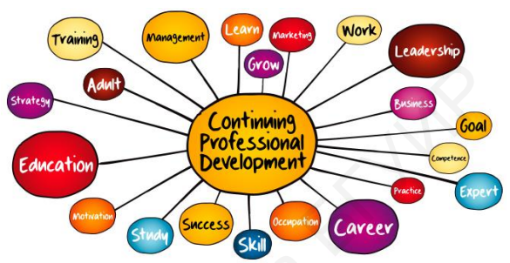

**Training and it’s forms**

Training is teaching. or developing in oneself or others, any skills and knowledge that relate to specific useful competencies. Training has specific goals of improving one's capability, capacity, productivity, and performance. In business, training is the investment of resources in the employees of a company, so they are better equipped to perform their job. The types of resources invested may include time and money to develop, implement, and evaluate training programmes.

The well-trained employee acquires an advantage for him- or herself. By participating in training, employees can deepen or expand their existing skill set and increase their understanding of the organisation. In addition, a well-trained employee may be able to take advantage of internal promotion opportunities and becomes more marketable if he or she leaves the company. Other potential benefits are as follows:

increased job satisfaction and morale among employees, increased employee motivation; increased efficiencies in processes, resulting in financial gain; increased capacity to adopt new technologies and methods; increased innovation in strategies and products; reduced employee turnover, enhanced company image, c.g, building a reputation as a "great place to work". Training provides greater skill and knowledge to employees, which, actually, leads to better job performance.

**The benefits of CPD**

CPD helps to ensure you have the knowledge and skills necessary to succeed as a professional. It helps you to build professional confidence and, in turn, the reputation of the profession; adapt positively to change by continuously updating skills support any career goals by focusing on relevant training and development; be more productive and efficient by reflecting on your learning and highlighting gaps in your knowledge and experience and planning action accordingly.